Q2.Implement Apriori Algorithm or use built in packages to find out the frequent itemsets and generate rules for frequent itemsets. Trace and submit the program output for the following given dataset of transactions with a minimum support of 3. (10M)

|  |
| --- |
| TID, Items |
| 101, A,B,C,D,E |
| 102, A,C,D |
| 103, D,E |
| 104, B,C,E |
| 105, A,B,D,E |
| 106, A,B |
| 107, B,D,E |
| 108, A,B,D |
| 109, A,D |
| 110, D,E |

ANSWER:

First, starting with loading the required packages.

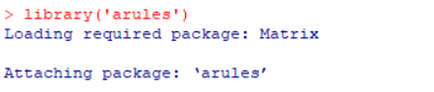

Now, in the below command, we setup working directory in our local system where the dataset file is located.

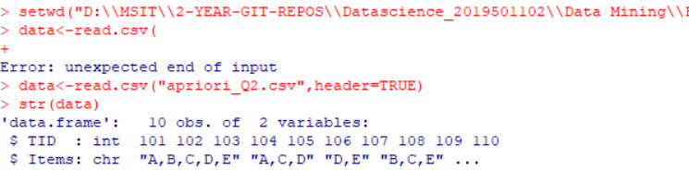

Str(data) gives the content or the dataset values.

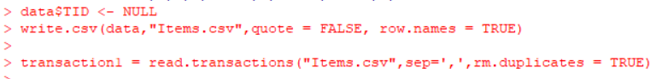

In the above, I am creating a csv file, where the items in dataset are separated by , delimiter.

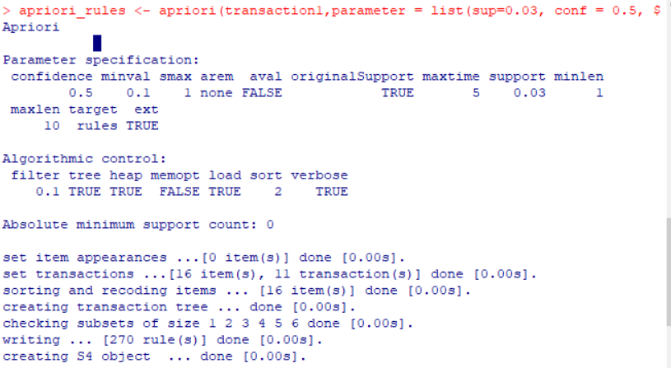

Above command defines the apriori rules that are applied for the dataset.

